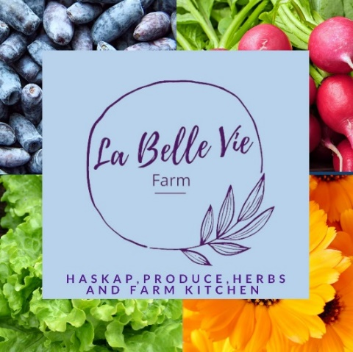

La Belle Vie Farm is an ecological farm growing haskap berries, salad greens, herbs and a small selection of seasonal vegetables. Our operation consists of: a berry orchard, terrestrial gardens, an indoor hydroponic/aquaponic farm and a certified on-farm kitchen. We are open to the public full-time during haskap season and part-time in the slower seasons. We attend local farmers’ markets, supply a few small retailers and sell direct to consumers via our farm store and website.

We are looking to hire staff for a number of positions in 2024 who are motivated to work hard, expand their knowledge of food production and processing systems, and work in a team environment to produce high quality, ecologically grown food, in a safe and efficient manner.

**JOB OPPORTUNITY: HASKAP ORCHARD LEAD LABOURER**

**Job Location**: 378 Turcot Rd., St Charles, Ontario with some local travel occasionally required

**Wages**: $17.00/hr, paid bi-weekly, with bonus harvest earning potential (to be discussed)

**Hours:** 35 hours per week as scheduled, including some evening and weekend work from June-August

**Diversity and Inclusion Statement:** The importance of community, diversity and inclusion are core beliefs at La Belle Vie Farm. As part of our commitment to inclusion, we strongly encourage youth from all backgrounds who meet the funder’s eligibility criteria to apply for this position. Our farm is a place where everyone is welcome. Diversity makes us stronger.

**\*IMPORTANT* Eligibility Criteria**: This opportunity receives funding through the federal Youth Employment Strategy. The candidate MUST be: between the ages of 15 and 30 years old (inclusive) at the beginning of employment; and be a refugee, a permanent resident, or a citizen of Canada at time of hire. Those who have temporary work permits are not eligible for this federal government funded position unfortunately.

**Job Description and Responsibilities:**

We are seeking an organized person, with a strong motivation to learn, and who has the capacity to lead others. The employee’s main role will be to assist with haskap orchard-related work. With guidance, forthright communication with the employer about all aspects of their work, and working as part of a team and independently, this employee will:

* facilitate the activities of the harvesting crews by ensuring a safe and efficient harvest
* communicate about harvesting standards and expectations with other harvesters
* harvest haskap berries, and other related activities.

The person in this position will also be responsible for:

* helping with receiving, washing, sorting and packing berries, as well as
* other farm labour and customer service duties as assigned when the harvest is not underway (e.g.: rainy weather, if the season is shorter than normal).

**Requirements:**

As this position will ideally involve operating an ATV and small trailer to assist with the harvest, candidates must be at least 16 years old, with a very strong preference for someone who has a G2 driver’s licence and ATV rider safety training.

**Additional Assets:**

The following are not required, but would be valuable to the position. Please mention any that are applicable in your application:

* G2 driver’s licence
* ATV rider safety training
* Fluency in both official languages (oral only)
* Experience with food, gardening, fish, animals, seed starting, farming
* Food Handler Certification
* Valid Standard First Aid
* Any prior leadership experience
* Previous haskap harvesting experience

*Please note that ALL candidates must be able to pass a Vulnerable Sector Police Screening if requested.

**Please submit your resume and cover letter labelled with your full name and the job title to:**

Tara Hamilton and Denis Turcot

La Belle Vie Farm

[labelleviefarm@gmail.ca](mailto:labelleviefarm@gmail.ca) (subject: Haskap Orchard Lead Labourer)